**Topic 3**

* Speed of network are express in bits per second (bps – e.g. 1 Mbps, 500Mbps, 1Gbps etc.)
* To connect a computer to a network, you need:
  + NIC (network interface card)
  + A medium (cable or radio waves)
  + An interconnecting device (switch or wireless router/access point)
  + Software:
    - Client software (e.g. web browser – chrome)
    - Server software (e.g. web server – apache)
    - Network protocols (e.g. tcp, udp, ip, icmp etc)
    - NIC driver (to drive the network interface card)

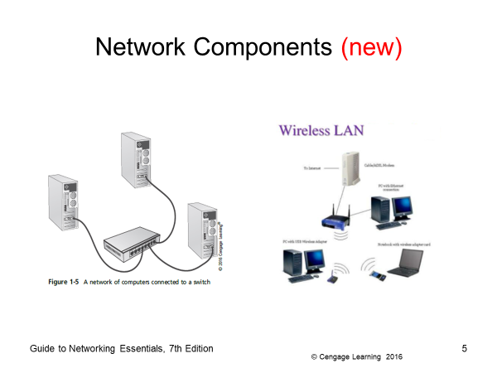

* What is an IP address?
  + 32 bit long
  + Express in dot decimal notation e.g. 192.1.2.55
  + It is logical address (not fixed), changes when your computer connects to a different network
  + Subnet mask or netmask tells which part is the network portion; and which part is host
  + 192.1.2.55/24 - netmask /24 or 255.255.255.0 tells us that the first 24 bits (192.1.2) is the network and remaining 8 bits (55)is for host
  + Number of hosts is 2n - 2 (where n is the number of host bits). The first address of the network is assigned to the network, and the last address is used as broadcast address

Using the netmask/subnet mask to derive the network address of an IP address

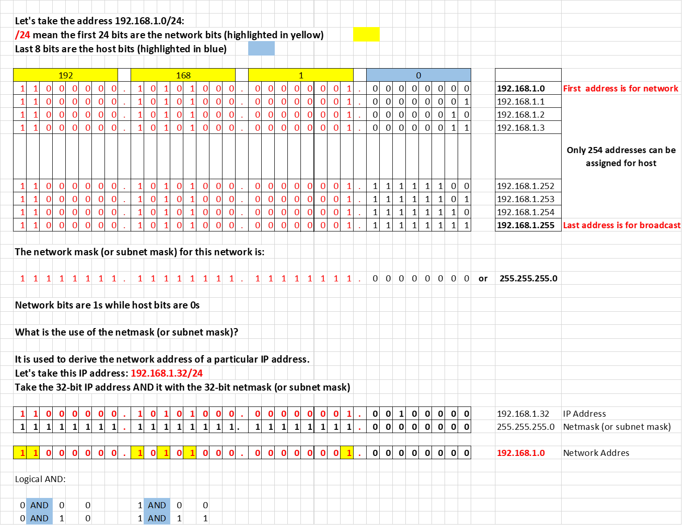

Subnetting Network into Subnets







* + Private IP addresses are:
    - 192.168.0.x to 192.168.255.x
    - 172.16.x.x to 172.31.x.x
    - 10.x.x.x

These addresses are not allowed on the Internet. To connect these private networks to the Internet, we need router that perform NAT (Network Address Translation)

* Public IP address vs Private IP address
  + Public IP addresses are recognised on the Internet, for your computer to access directly to the Internet, it must have a public IP address
  + Private IP addresses are not recognised on the Internet, but only for private use in a private network
  + Private IP addresses are in these range:
    - 192.168.0.x to 192.168.255.x
    - 172.16.x.x to 172.31.x.x.
    - 10.x.x.x
  + In order of computer with private IP address to access the Internet, it has to be converted to a public IP address through NAT router.
* What is MAC address?
  + A hardware address burnt-in a network interface card
  + It is physical, does not change
  + 6-bytes long express in Hex e.g. 00-0c-09-fa-cc-de
  + First 3 bytes is the manufacturer code, second 3 bytes in the serial number of the card
* Which command do you use to check your IP address?
  + ipconfig /all
  + These 4 pieces of information must be configured in every computer connected to the Internet (or TCP/IP network):
    - IP address
    - Subnet mask (or netmask)
    - IP address of your router (or gateway)
    - IP address of DNS (Domain Name Server)
    - It can be set manually or automatically using DHCP (Dynamic Host Configuration Protocol).
    - DHCP server assigns these to your computer when it connects to the network
* What is LAN, WAN, MAN?
  + LAN covers a small geographical area (like a house, small office or building)
  + MAN covers a small town/city or a campus
  + WAN covers the whole world (example the Internet)
* What is an internetwork?
  + When two or more LANs are connected by routers – it forms an internetwork. Internet is the biggest internetwork.

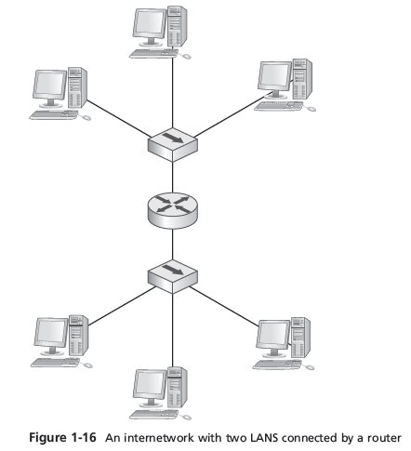

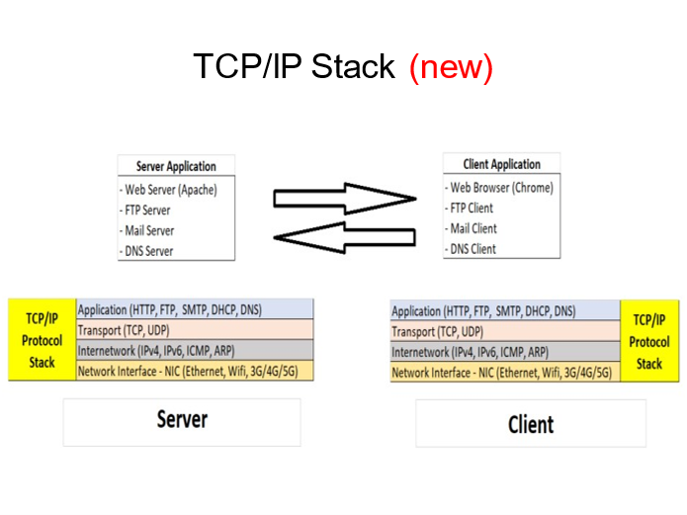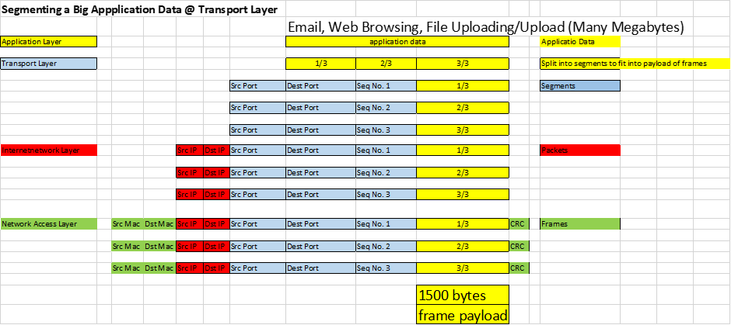

* What is a packet?



a chunk of data with a source and destination IP address added to it (routers route packets between networks)

* What is a frame?



a packet with the source and destination MAC addresses added to it

The packet is “framed” by the MAC addresses on one end and an error-checking code on the other (NIC sends and receives frames)

* In a network, data are transferred in frames (carry packets) in burst. Why?
  + Pause between bursts allows other computers to transfer data during pauses
  + Allows the receiving computer to process received data
  + Allows the receiving computer receive data from other computers at the same time
  + Gives the sending computer an opportunity to receive data from other computers and perform other processing tasks
  + If an error occurs during transmission of a large file, only the chunks of data involved in the error need to be sent again (not the entire file)

**Links to video:**

1. **IP address**

<https://www.youtube.com/watch?v=vrh0epPAC5w&t=3590s>

**Subnet Mask**

https://youtu.be/vrh0epPAC5w?t=4093

**CIDR**

https://www.youtube.com/watch?v=s_Ntt6eTn94&t=998s

**Dynamic vs Static IP Address**

[**https://youtu.be/vrh0epPAC5w?t=4618**](https://youtu.be/vrh0epPAC5w?t=4618)

1. **MAC Address**

<https://www.youtube.com/watch?v=vrh0epPAC5w&t=3250s>

1. **Private IP vs Public IP Address**

[**https://www.youtube.com/watch?v=po8ZFG0Xc4Q**](https://www.youtube.com/watch?v=po8ZFG0Xc4Q)

1. **NAT/PAT Explained**

<https://www.youtube.com/watch?v=FTUV0t6JaDA>

1. **DHCP Explained**

<https://www.youtube.com/watch?v=e6-TaH5bkjo>

1. **Ping command**

<https://www.youtube.com/watch?v=IIicPE38O-s>

1. **Internal workings of NAT/PAT**

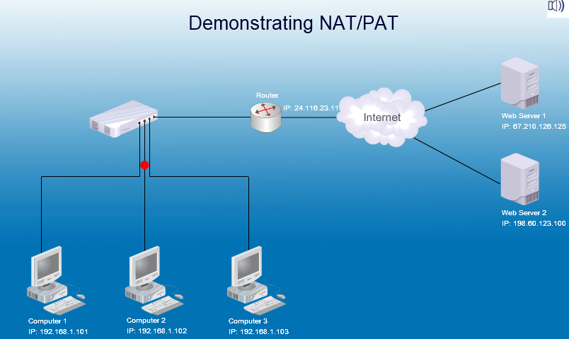

Scenario:

1. Web Browser (Port: 3569) on Computer 1 (192.168.1.101) is communicating with Web Server (Port: 80) on Web Server 1 (67.210.126.125)
2. Web Browser (Port: 7905) on Computer 2 (192.168.1.102) is communicating with Web Server (Port: 80) on Web Server 2 (198.60.123.100)
3. Router public IP address is: 24.116.23.11

Below is the NAT Translation Table on the Router:



Practical 5 Ping

1. Ping 127.0.0.1 (loopback test)
2. Ping -4 localhost (loopback test – same as 127.0.0.1)
3. Ping your_ip_address
4. Ping a computer on your network
5. Ping your router
6. Ping a host on the Internet by IP address
7. Ping a host on the Internet by name

